
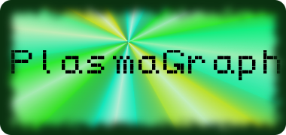

Software Project Management Plan

for

PlasmaGraph

Version 2-2014-05-12

Daniel E. Quintini (# 73749) |  | Gerardo A. Navas (# 69615)
Computer Science Undergraduate Program |  | Computer Science Undergraduate Program
Polytechnic University of Puerto Rico
May 12, 2014

Advisor: Prof. Luis A. Ortiz Client: Prof. Angel Gonzales-Lizardo
Revision History
Version | Date | Reason For Changes
1-2013-11-11 | Friday, November 11, 2013 | First version of document.
1-2014-04-27 | Sunday, April 27, 2014 | Changes to title page, page numbers, addition of a preface, page numbers on the Table of Contents, addition of various tables and lists for terms and the like, general sentence reorganization all around the document, and additional information provided for group member roles.

Preface
This document, the Software Project Management Plan, exists to detail the organization of the Plasma Visualization Group's PlasmaGraph project. It is specifically-designed to communicate how the project will begin, progress, and what are its end goals, but not what the project entails. Those reading this document should be interested in understanding facets of the management of this project.

Table of Contents
1. Introduction 1
1.1. Project Overview 1
1.2. Project Deliverables 1
1.3. Evolution of the SPMP 2
1.4. Reference Materials 3
1.5. Definitions and Acronyms 3
2. Project Organization 5
2.1. Process Model 5
2.2. Organizational Structure 6
2.3. Organizational Boundaries and Interfaces 6
2.4. Project Responsibilities 7
3. Managerial Process 8
3.1. Management Objectives and Priorities 8
3.2. Assumptions, Dependencies, and Constraints 10
3.3. Risk Management 10
3.4. Monitoring and Controlling Mechanisms 12
3.5. Staffing Plan 17
4. Technical Process 19
4.1. Methods, Tools, and Techniques 19
4.2. Software Documentation 20
4.3. Project Support Functions 21
5. Work Packages, Schedule, and Budget 22
5.1. Work Packages 22
5.2. Dependencies 25
5.3. Resource Requirements 28
5.4. Budget and Resource Allocation 30
5.5. Schedule 31
Appendices 31
Appendix A: Project Resources and Budget 31
Appendix B: Project Schedule Gantt Chart 31

List of Figures
Figure Page
Figure 1: Team Organizational Structure 6
Figure 2: Main Directory Organization 13
Figure 3: PlasmaGraph Directory Organization 13
Figure 4: Specs Directory Organization 14
Figure 5: Work Package Dependency Diagram 24
Figure 6: "PlasmaGraph Program" Work Package Dependency Diagram 25

List of Tables
Table Page
Table 1: Document Definitions 3
Table 2: Document Acronyms 4
Table 3: Intermediary Document and Image Formats 19
Table 4: Work Package Labels 21
Table 5: Software Used in Project, Ordered by Purpose 27
Table 6: Resources Used by Work Packages 29

1. Introduction

1.1. Project Overview
This document will cover the current plan for the creation of the PlasmaGraph graphing tool for the Polytechnic University of Puerto Rico's (PUPR's) Plasma Laboratory. PlasmaGraph is a graphing tool, enabling easier graphing capabilities compared to those of MathWorks' Matlab product, the product currently in use by the Plasma Lab. A number of basic capabilities will be included with this initial product; they will be listed and described in the Software Requirement Specification (SRS) document included with this document.

Two PUPR Computer Science students will take part in this project as group members and implement all requirements as they appear in the SRS. Progress in this project will be measured by the completion of particular milestones, which will be deliniated in Part 5 of this document, “Work Packages, Schedule, and Budget”. Completion will be measured by how the product completes the testing detailed in the Software Test Documentation (STD), also included with this document. Once completed, this project will form a part of the continuity of physical and digital systems currently in use by the PUPR Plasma Laboratory to pull data out of their experiments and understand them.

1.2. Project Deliverables
The client, Professor Angel Gonzales-Lizardo of the Polytechnic University of Puerto Rico's Plasma Laboratory, must receive the following items at his office in the PUPR Plasma Lab by <Enter Date Here> at <Enter Time Here> AST:

A. One (1) digital copy of the PlasmaGraph product, program documentation, and user manual in a CD-ROM.

B. One (1) physical (paper, softcover) copy of the PlasmaGraph User Manual.

C. One (1) physical copy of the following specification documents:
1. The Software Project Management Plan (SPMP)
2. The Software Requirements Specification (SRS)
3. The Software Design Description (SDD)
4. The Software Test Document (STD)

D. One (1) digital copy of all presentations performed throughout the duration of the project.

E. One (1) physical poster summarizing the project.

The aforementioned material will be used to evaluate the quality of the work performed in the project for the purpose of confirming successful completion of the project's requirements as defined in the SRS..

1.3. Evolution of the SPMP
The SPMP will only be changed by the Project Manager.

This document will be made in parts, each of which will be created and modified on its own, as an individual document. When changes are finalized, the parts will be compiled into one document and given an incrementing version number. (r1, r2, r3, etc.) Therefore, the first version of the SPMP will be named "Software Program Management Plan r1.pdf", and the following versions will have their version number increase.

All components related to the creation of the SPMP will be located in the project's GitHub version control system, (https://github.com/TakoArishi/PlasmaGraph) under the directory “specs/SPMP/”. Document fragments will be divided by the section they are located in (Folders labelled Sections 1 through 5 in said subdirectory.), and completed documents will be divided by version. (Folders labelled either "Current Version" or "Previous Versions" in said subdirectory.) GitHub will manage the myriad files that the project will require and allow the project to recover from most catastrophic losses of data, if and when they occur.

1.4. Reference Materials
- IEEE Standard for Software Project Management Plans," IEEE Std 1058-1998 , vol., no., pp.1,28, Dec. 22 1998.
<http://ieeexplore.ieee.org/stamp/stamp.jsp?tp=&arnumber=741937&isnumber=16012>.
- All Definitions and Acronyms: Dictionary.com Unabridged. Random House, Inc. 28 Apr. 2014. <Dictionary.com http://dictionary.reference.com/>.

1.5. Definitions and Acronyms
Table 1: Document Definitions
Term | Definition
PlasmaGraph / Product | A Matlab-file error-checking graphing program made for the PUPR Plasma Laboratory.
Client | Professor Angel Gonzales-Lizardo; the person requesting the project.
Senior Project Professor | University-designated overseer of the project's progress.
JFreeChart | A set of tools written in the “Java” programming language that create graphical representations of data provided to it.
Java | Object-oriented, interpreted programming language known for its portability between multiple operating systems and general-purpose capabilities.
Operating System | Program designed to manage a computer's hardware resources automatically and provide a foundation for other programs to run correctly, efficiently, and safely.
Project Group / Group | The creators and maintainers of the project and all of its end products. Composed of Gerardo A. Navas Morales and Daniel E. Quintini Greco.
GitHub | File repository system that uses the Git Version Control System.
Version Control System | Manages how multiple users can access and change the same files without losing data. Also known as a Revision Control System or Source Control System
Integrated Development Environment | Type of computer program that provides programming tools to ease development and maintenance of other software products.
Vetting work packages | The process of reviewing a work package for semantical errors, documentation requirements (if a document), or programming errors (if a program).
Polytechnic University  of Puerto Rico | University where the Plasma Laboratory is located, as well as where the group's members study.
Software Project Management Plan | This document; One of the four IEEE project documents being created as part of this project.
Software Requirements Specification | One of the four IEEE project documents being created as part of this project.
Software Design Document | One of the four IEEE project documents being created as part of this project.
Software Test Documentation | One of the four IEEE project documents being created as part of this project.
Graphical User Interface | A software interface designed to standardize and simplify the use of computer programs by using a mouse to manipulate text and images on a display screen featuring icons, windows, and menus.
Development | Creation of product code.
PNG / .png / JPG / JPEG /  .jpg / .jpeg | Types of computer files that hold image data.
MAT / .mat | Matlab data file format.

Table 2: Document Acronyms
Term | Acronym
PUPR | Polytechnic University of Puerto Rico.
SPMP | Software Project Management Plan.
SRS | Software Requirement Specification.
SDD | Software Design Document.
STD | Software Test Documentation.
GUI | Graphical User Interface.
VCS | Version Control System
IDE | Integrated Development Environment.

2. Project Organization

2.1. Process Model
The “Work Packages” section of this document (Section 5.1) details the necessary components of this project and each of their requirements. Team members will tackle the completion of project deliverables in vertical order. (top to bottom) The project will begin with initial drafts of the SRS and SPMP documents in order to specify the product's requirements and project's management, and will end when all work packages are completed.

The following must occur before any work on a work package with pre-requisite work packages may begin:
- An initial draft of the previous work packages must be finished. For the purposes of this project, an “initial draft” consists of either a first draft of a document or presentation vetted by a project member as sufficiently completed to continue, or a version of the product that has passed the automated tests described in the STD.
- A request to begin work on a work package must be made to the Project Manager, and they must vet the initial draft of the pre-requisite work packages.

Once a work package is verbally approved to be started, the project memberrs may begin to contribute to the work package until its completion. For the purposes of this project, a completed work package requires following:
- A final draft of the work package that is vetted by a project member.
- Inclusion of the final draft and all materials used to create it into the main branch of the project repository, if said draft was created in a separate branch.
- Inclusion of the final draft into the folder named “Documentos Finales” in the “specs” folder of the repository.

2.2. Organizational Structure
This project will be completed by the following people: (Their positions are included in parentheses)
- Gerardo A. Navas Morales (Project Manager)
- Daniel E. Quintini Greco (Design Manager)

As shown in the following diagram, the positions of these two project members are equivalent to one another with regards to project management hierarchy:
Figure 1: Team Organizational Structure
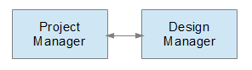

2.3. Organizational Boundaries and Interfaces
The project team will handle the following items related to the project:

a. Research and development of the project's product and documentation.
b. Presentation of the product to the client.
c. Meetings with the client.
d. Transferral of all work packages to client.

2.4. Project Responsibilities
As described in section 2.2 of this document, this project's team is composed of two (2) members. The duties that these two members must perform either fall in two categories: those that will be shared and those that will not be shared.

The following are those duties that will overlap:
1. Research, design, develop, and maintain product.
2. Develop and maintain product documentation.
3. Manage meetings with the client and present progress when requested.
4. Develop and present product presentation according to the Work Package diagram. (Section 5.1)
5. Provide all materials to the client when the project is finished.
The following are those duties that do not overlap:

Project Manager
    - Develop and maintain the SPMP and SDD documents.
    - Manage weekly project updates.
    - Maintain GitHub information repositories.

Design Manager
- Develop and maintain the SRS and STD documents.
- Schedule and oversee end user (Plasma Laboratory personnel) testing.
- Serve as intermediary between Project Manager, Client, and Plasma Laboratory personnel.

3. Managerial Process

3.1. Management Objectives and Priorities
This section will cover what the project goals are and how the team will reach them.

A. Purpose
This project team was organized in order to create a product, named “PlasmaGraph”, for the client. This product will be able to take a Matlab Level-5-formatted data file and the graph details (settings), and will provide a graph containing the data and settings selected. The client has requested this tool to try to supplant some of the uses of Matlab in the Plasma Laboratory he oversees.

B. Priority
The project is divided into two general sections: the program (the working product, including its code documentation) and its documentation (its specifications and the user manual that will be provided alongside the product). The priorities for each are as follows:

1. Documentation Priority: The documentation for the project is required to be able to begin developing the product; therefore, the documentation will take priority over the product.

2. Product Priority: The team will not begin development on the product until initial drafts of the SRS and SPMP work packages have been completed.

C. Communication and Meetings
Team members may communicate with each other via e-mail, telephone conversations, text messages, instant messenging, and physical meetings, both official and unofficial. Group members will exchange telephone contact information during the first official meeting of the project group, and may provide additional contact vectors as needed.

Official meetings will be decided upon at least one day in advance, and must last for at least one hour. The ideal period of time for meetings will be on Tuesdays or Wednesdays from 4:00 PM to 6:30 PM, but meetings may be scheduled for any point in time that does not conflict with University classes or other jobs' work schedules. Unofficial meetings follow the same pattern, but need not be constrained to the minimum time requirement that official meetings are.

Meetings with the Senior Project Professor and the Client will all be official. Meetings with the former will be held weekly in Room 2 of the EPL, Room L-309, or Room L-310 (Save during the weeks between terms or during university vacation time.) and will be logged via meeting notes (specs/Notas de Reuniones/) that will be signed by all team members, describing what has been done during the week and what should be done for the following week. Meetings with the latter will not be recorded in the same way; instead, the project team will meet with him with a number of questions and will end the meeting when questions have been answered and when all the requests by the client have been answered satisfactorily.

D. Schedule
Refer to Section 5.5 of this document for how the project's schedule will be organized.

E. Budget / Resources
Refer to Sections 5.3 and 5.4 for how the project's budget and resources will be used and allocated.

3.2. Assumptions, Dependencies, and Constraints
Constraints
    - The product must be able to process Matlab Level-5 data files of 36500 KB or less.
    - The product must be portable enough to be used on most platforms with minimal installation work.

Assumptions
- The system WILL accept files in the "MAT" format as user input.

Dependencies
None. This project is not a branch of any other projects.

3.3. Risk Management
Problematic situations may occur throughout the duration of this project. This list will detail what are the measures that will be taken to minimize risk:

A. Project Members
- Constant communication is mandatory, whether through phone, e-mail, or meetings on university grounds.
- Whenever a meeting is scheduled, all project members must participate in that meeting. Persons that do not participate in at least half the group meetings without valid reasons will be removed from the project group.
- Work will be divided evenly. In such a case that a member believes the task given to them are uneven or unsuited to them, they can bring up the complaint to the Project Managerer via any communication medium.
- If a project member does not participate in a meeting, they must be contacted via any communication medium to update them of the meeting's main topics, and the member must send confirmation of having received the information. This avoids leaving members without vital information.
- All project members must perform roughly equal work to be credited properly. (For the purposes of this point, "roughly equal work" refers to a 50/50% split, with a variance of 15%.) Any members that do not comply with this rule will be removed from the team.
- If the document-hosting service or the code-hosting service is terminated by either the Project Manager or a third party, the Project Manager's version of these documents or code will be used as the basis of all future development. These files will then be uploaded onto another service with similar privacy protection as agreed upon by the Project Manager. Once this is done, this change must be communicated to all project members via any medium, and must explain the change and how to access the new versions.

B. Client
- Meetings with the Client will occur when a milestone has been reached, but communication regarding the group's current progress should occur periodically so as to provide some amount of feedback to the Client.
- Meetings with the Client will have their primary points written down so as to record the content of the discussions.
- Features requested after the first meeting are not guaranteed to appear in the first version of the finished product. Instead, they will be accomodated as possible into the schedule.
- If the Client wishes to drop the project, the project will continue to its conclusion, relying on the Senior Project Professor as backup client.

C. Senior Project Professor
- Meetings with the Senior Project Professor will occur weekly on Thursdays at 4:00 PM to 4:30 PM either in Room 2 of the EPL lab, Room L-309's side room, or Room L-310. Project group members will come with a log of their weekly accomplishments and the following week's proposed tasks.
- If a certain part of the project requires multiple rounds of feedback from the professor, additional meetings between the project member(s) and the professor should be scheduled throughout the week.
- If the Senior Project Professor finds himself unable to continue work on the project or unwilling to provide adequate feedback on the components for multiple months for whatever reason, the project members will submit a request to the university (PUPR) for a new professor willing to provide assistance to the project.

3.4. Monitoring and Controlling Mechanisms
We will discuss how this product will be distributed and managed during its development in this section.

A. Project Repository
The PlasmaGraph project's files will all be distributed and managed via the project's GitHub page. GitHub is a version control system designed to manage multiple versions of files, allowing for easy access while providing excellent error-correction mechanisms. The primary version of the project is called the “master”, whereas all other versions are called “branches”.

The GitHub repository may be manipulated either via the official website (www.github.com) or via any of the myriad tools that can interact with repositories via the Git system. Refer to the tool's instructions on how to perform certain Git actions when necessary.

The following is a list of rules that must be adhered to while contributing to the project:
- All team members must request Contributor status to the Project Manager in order to contribute to the project.
- All members must create a new branch in order to begin work on any section of the project.
- Work must be performed on the member's own branch, unless requested to by the branch owner or the Project Manager. Refer to C. Repository Management for details regarding the logging of changes into the GitHub repository.
- When work is finished on a branch, a pull request must be initiated by the branch owner. The Project Manager will then evaluate the work. If the branch passes its tests and / or has completed its purpose, then the Project Manager will merge the new branch into the master branch.

The project's GitHub web page is located in: https://github.com/TakoArishi/PlasmaGraph

B. Repository Organization
The project's GitHub repository will be structured in the following format:
Figure 2: Main Directory Organization
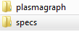
The main directory will contain two different folders:
- The “plasmagraph” folder contains the contents of the Work Packages labelled “PlasmaGraph” and “Code Documentation”. (See Section 5.1.)
- The “specs” folder will hold the contents of any work package that isn't held in the “plasmagraph” folder. (See Section 5.1.)

The “plasmagraph” directory will contain the following sub-directories:

Figure 3: PlasmaGraph Directory Organization
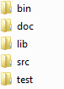
- The "bin" directory will hold the compiled versions of the product.
- The "doc" directory will hold the JavaDocs created as a result of the code documentation. (See Work Package B1 in section 5.1 of this document for more details.)
- The "lib" directory will hold the additional libraries used by the project via the JAR files located within; linking to this via the Eclipse "External Libraries" feature will allow access to the support functions that they provide.
- The "src" directory will hold the entirety of the Eclipse workspace; this way, all the relevant files that directly form a part of the PlasmaGraph product will be easily saved in the repository.
- Finally, the "test" directory will hold the environment for testing the product, including sample test data and test template data.

Finally, the “specs” directory will contain these sub-directories:
Figure 4: Specs Directory Organization
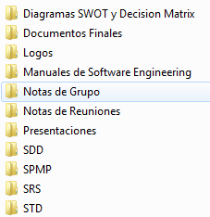

- The “Diagramas SWOT y Decision Matrix” sub-directory will contain all diagrams and materials used in the programming language and tools decisions made at the start of the project.
- The “Documentos Finales” sub-directory will contain the release-ready versions of the SRS, SDD, STD, and SPMP documents; that is, the documents in this sub-directory will be actualized for the currently-released version.
- The “Logos” sub-directory will contain all logos related to the PlasmaGraph project or the Plasma Visualization Group team.
- The “Manuales de Ayuda” sub-directory will contain all supplementary documents used for the creation and maintenance of the project and all its work packages.
- The “Notas de Grupo” sub-directory will contain all notes that are important for the functioning of the team.
- The “Notas de Reuniones” sub-directory will contain all meeting notes between the team and the client or any other external party.
- The “Presentaciones” sub-directory will contain all the project's PowerPoint presentations and their respective materials.
- The “SDD”, “SPMP”, “SRS”, and “STD” sub-directories will contain their respective documents, along with all the images, diagrams, and other such fragments that comprise them.

C. Repository Management
Each project member will maintain their own personal version of the project's contents; this is known as a "branch" in GitHub. This will serve to isolate their changes and manage their individual work until it (their work) is ready to be added to the main branch's ("master") contents. This section will discuss how the project members will perform these changes, view their changes, and include their work into the project's "master" branch.

- Documenting Changes
Project members must follow the following rules while logging changes to the GitHub repository:
- First, members must add all files to be logged via the Git command “Add”.
- Second, the Git command “Commit” must be used to document the changes via a descriptive message of the important changes in the update.
- Finally, the Git command “Push” will synchronize the changes to the member's branch in the GitHub repository.

- Reviewing Changes
Changes can be reviewed via the GitHub project's "Commits" page. The commits of branches that aren't the main one can be accessed by navigating to the "Branches" viewing option and selecting the desired branch, then viewing the "Commits" for that branch.

- Moving Changes to the Master Branch
When a sufficiently-large milestone has been reached in a branch (such as when a specification document like the SRS / SDD / STD / SPMP is completed), said data should be moved to the main branch via the Pull Request function. To do so:
- The team member must create a new Pull Request between the “master” branch and their branch and include the request's reason as a comment.
- Once done, the member will discuss the situation with the Project Manager, allowing the Project Manager to approve or deny it as she or he sees fit.
- If valid, the Project Manager will merge the two branches.

This process allows other project members to routinely take advantage of new work related to the project without sacrificing much of the main branch's quality.

D. Problem Resolution
Solution to possible repository problems that may arise will be considered on a per-situation basis. The Project Manager should discuss the options available with the Design Manager before deciding on a course of action.

3.5. Staffing Plan
A minimum of two persons will be required to complete this product, both of which should have various qualifications, although training is available for potential members with lack of experience with certain programming tools. These persons, as well as the requirements for each, are as follows:

A. Project Manager
The Project Manager is the director of the team, orchestrating the meetings between the client and team members, maintaining the SPMP and SDD, and managing the tools used by the group.

This person must be a student at the Polytechnic University of Puerto Rico. Furthermore, the person must have previous experience with working with IEEE project design documents, namely the SRS, SDD, STD, and SPMP documents, and should have extensive university-level class experience in programming and program design. Said person should also have some experience with managing a team, but this is not vital to the role of this member, as the group size is small. They should also have extensive experience with the programming language being used in the project, so as to act as reference for any other team members.

B. Design Manager
The Design Manager is the other part of the success of this project; said person is the mastermind of the SRS and STD, detailing what functions the product will perform and how will these functions be tested to ensure their compliance to the client's request.

This person must be a student at the Polytechnic University of Puerto Rico. Furthermore, the person must have previous experience with working with IEEE project design documents, namely the SRS, SDD, STD, and SPMP documents, and should have extensive university-level class experience in programming and program design. It is recommended for them to have some experience with the programming language being used in the project so as to reduce training time.

Any elimination of current personnel must be done with (1) a new qualified person ready for immediate assignment, and (2) the approval of all university faculty overseeing completion of the course, including the Senior Project Professor if s/he is not being substituted. Changes in personnel should be directed to the Client(s) in the interest of keeping them abreast of the group's status.

Training will be provided by the Project Manager or Design Manager to the new member(s) of the project group as needed.

4. Technical Process

4.1. Methods, Tools, and Techniques
The data-graphing program PlasmaGraph must follow these requirements:

A. During Product Development:
- Programming Language
Java Version 7 will be used to create the product.

- Integrated Development Environment (IDE)
The Integrated Development Environment (IDE) used to develop and test the product must be either Eclipse or NetBeans IDE.

- Operating System
The Operating System (OS) used to create this program must be any version of Windows, Mac, or Linux that can run the IDE programs mentioned above in the section “Integrated Development Environment (IDE)”.

- Code and Document Repository
GitHub will contain this product's code and documentation for the duration of its development.

- Intermediary Document and Image Formats
The following table details the possible formats for any components of the “Project Documentation” and “Code Documentation” Work Packages. (See Section 5.1)
Table 3: Intermediary Document and Image Formats
Document | Extension
Diagramming Document Format(s) | .dia
Text Document Format(s) | .txt, .doc, .docx, .md
Code Document Format(s) | .java
Image Format(s) | .png, .jpg, .jpeg

B. Product Usage:
- Java Version
Java Version 7 or newer is required to run this program.

- Operating System
The Operating System (OS) used to run this program is any OS can run Java Version 7 or newer.

4.2. Software Documentation

Software documentation explains what the product's code does in order to fulfill the client's requiements. The Java-provided tool “JavaDoc” will be used to create this documentation. To do so, however, the following rules must be adhered to:

- Each Java Package, Class, and Method must be documented via JavaDoc comment format. [Cite reference]
- All Java Packages must contain the following JavaDoc comment components in their “package-info.java” file in order:
  - Package content summary.
  - One “@author” tag. The default author for this project is “Plasma Visualization Group”.
- All Java Classes must contain the following JavaDoc comment components in order:
  - Class summary.
  - One “@author” tag. The default author for this project is “Plasma Visualization Group”.
- All public Java Methods must contain the following JavaDoc comment components in order:
  - Method summary.
  - One “@param” tag per method parameter.
  - One “@return” tag, unless the method is a void method.

4.3. Project Support Functions
This project requires various minor functions in order to operate certain sections and guarantee quality.

A. Software Quality Assurance

The quality of the final product will be confirmed in three ways:

- Mutual Oversight: As both the Project and Design Managers will work on the project code, they must both communicate to each other while they collaborate on the project, explaining how their contributions help progress to the final goal.

- Software Documentation: All programmers (Project Manager and Design Manager) must document their code; this not only allows others to understand the product's internals better, but also allows everyone participating, themselves included, to catch the code's errors.

- Testing: Please refer to the STD for information regarding how the product will be tested.

B. Configuration Management

- Initial IDE Configuration: Initial configuration of the development environment will be explained via the “README.md” file located in the root of the GitHub repository.

- Final Product Configuration: Configuration details of the final product's environment will be detailed in the supplementary User Manual (Work Package B2) that will be provided with the product.

5. Work Packages, Schedule, and Budget

5.1. Work Packages

The project team must implement all of the requierments stipulated in section 2.2 of the SRS. To do so, the team must complete the following components, known as Work Packages:

Table 4: Work Package Labels
Work Package | Package Label
Project Documentation | A
Software Requirement Specification (SRS) | A1
Software Design Description (SDD) | A2
Software Test Document (STD) | A3
Software Project Management Plan (SPMP) | A4
PlasmaGraph Program | B
Data Reading Module | B1
Data Graphing Module | B2
Program Graphical User Interface | B3
Program Documentation | C
Code Documentation (Javadocs) | C1
User Manual | C2
Project Presentations | D
“Product Requirements” Presentation | D1
“Using PlasmaGraph” Presentation | D2
Final Project Presentation | D3

The following explanations will describe the purpose of each work package mentioned above:
A. Project Documentation
A1. Software Requirement Specification (SRS)
This document describes the product from an external viewpoint. It specifies the key features of the product as requested by the client, as well as what the product needs in order to perform its functions.

A2. Software Design Description (SDD)
This document details the product's internal structure and how it performs its most crucial processes in a step-by-step manner via the use of various types of UML diagrams.

A3. Software Test Document (STD)
This document details the different tests that prove the product adheres to the requirements specified by the client and written in the SRS.

A4. Software Project Management Plan (SPMP)
This document describes the project's team structure, objectives, tools, and plan to create the product described in the SRS and SDD.

B. PlasmaGraph Program
B1. Data-Reading Module
This product component extracts the data contained in the given Matlab Level-5 file and creates various containers for the data. This component also verifies that the file provided is valid to be graphed and, if another module requests the data under a pair of columns, will verify that each row contains valid data.

B2. Data-Graphing Module
This product component obtains a file to be graphed, the columns to graph, and the visual modifications to perform on the created graph and creates a graph if the desired columns of said file with the selected modifications.

B3. Program Graphical User Interface
This product component provides the user with a visual interface to interact with the various tools that this program contains. This component makes this program much quicker and easier to use than Matlab in most cases. It also contains the necessary code to connect the Data-Reading and Data-Graphing Modules.

C. Program Documentation
C1. Code Documentation (Javadocs)
The Javadoc documentation allows any interested party to understand the inner workings of the product's code. With this, the Plasma Laboratory will be able to better understand the work done by this project's team and be better equipped to add additional functionality to the product if desired.

C2. User Manual
The User Manual allows potential users to better understand how to use the program by explaining how to perform certain functions.

D. Project Presentations
D1. “Product Requirements” Presentation
This presentation will showcase the work performed in the initial drafts of the SRS and SPMP documents before work begins on the SDD and product itself.

D2. “Using PlasmaGraph” Presentation
This presentation is primarily directed to the students of the Plasma Laboratory and will showcase how to interact with the PlasmaGraph program. It will contain both a step-by-step description of how to perform certain functions as well as explanations on how certain functions create their results.

D3. Final Project Presentation
This presentation is directed to all interested parties in the Polytechnic University of Puerto Rico. It will present an overview of the project, describing what the team was requested to create, what it made, and how it created it.

The components of the Project Documentation (A) are detailed in the IEEE 830 / 1016 / 829 / 1058 document standards. Furthermore, all presentations will be created via a "Powerpoint" program and will contain information from other work packages, carefully selected so as to showcase important aspects of the project's progress.

5.2. Dependencies
The following graphs describes the tree-like structure of how work packages will be developed.
Figure 5: Work Package Dependency Diagram
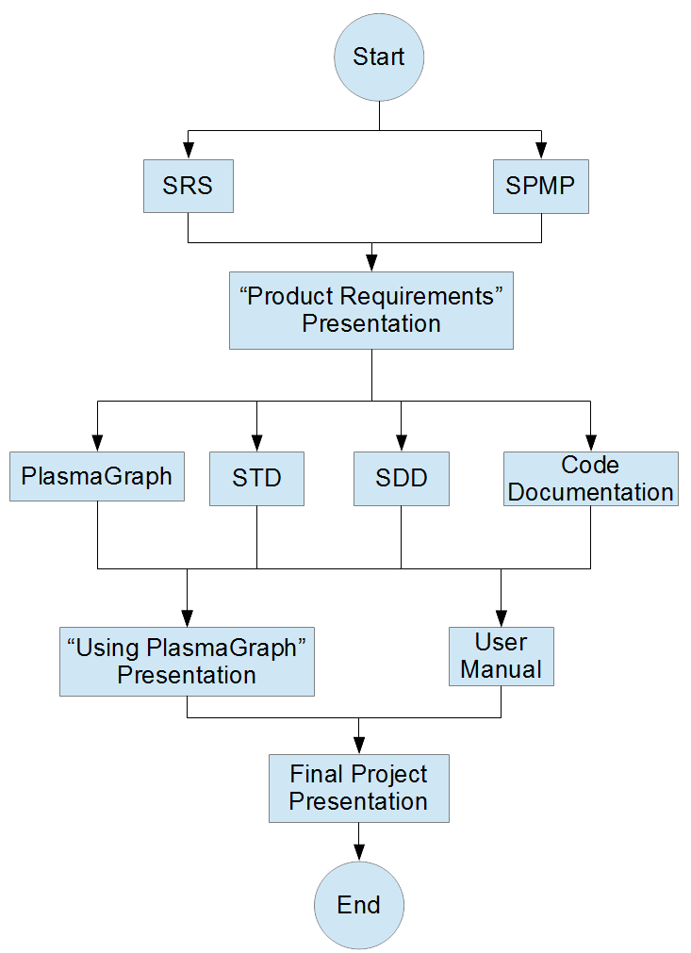
Figure 6: "PlasmaGraph Program" Work Package Dependency Diagram
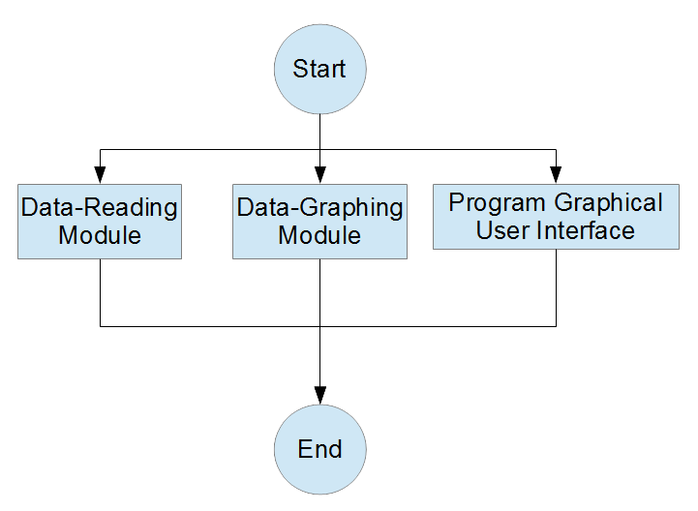
As presented in these diagrams, each set of concurrent work packages is presented in a different row. In order to continue to the next row, each work package in the current row must pass the initial draft process detailed in Section 2.1 of this document. The deadline for the final versions of all of the work packages of this project is to be the day of the Final Project Presentation.

5.3. Resource Requirements
The following resources will be needed for the completion of this project:

A. Hardware and Software
1. Hardware
The project group will utilize their own computers (laptops and/or desktops), as well as the desktops in the PUPR Computer Lab located in P-103 to complete all work packages as detailed in section 5.1 of this document.
2. Software
The project group will use a number of software programs in order to complete the work packages:

Table 5: Software Used in Project, Ordered by Purpose
Software Purpose | Software Used
Diagramming Software | OpenOffice Draw, Microsoft Visio 2013, Dia
Document Software | Microsoft Word 2013, OpenOffice Writer, OpenOffice Calc, Sublime Text 2, Sublime Text 3
Scheduling Software | Microsoft Project 2013
Presentation Software | Microsoft PowerPoint, OpenOffice Impress
Programming Software / IDEs | Eclipse, Netbeans IDE
VCS | Git, GitHub
Image-Manipulation Software | GIMP, Paint.NET, MSPaint
Research Software | Mozilla Firefox, Google Chrome

B. Temporary and Permananent Locations
1. Temporary Locations
The following locations will be used:
- PUPR Campus - Library - Study Rooms: Project teem meetings.
- PUPR Campus – Classroom P-103: Project team meetings and client meetings.
- PUPR Campus - Classrooms L-310, EPL-2: Meetings with Senior Project Professor.
- PUPR Campus - Plasma Laboratory: Meetings with Client.
- PUPR Campus - <final presentation room>: Final Presentation.
2. Permanent Locations
No permanent locations will be needed for the purposes of completing this project.

C. Human Resources
The Project and Design Managers will work on all work packages except the SRS, STD, and SPMP packages. The Project Manager will manage the GitHub file repository. Presentations will be given by both members. The team will rely on university faculty to review their SRS, SDD, STD, and SPMP documentation.

D. Meeting Logs
Meeting Logs will be maintained by the Project Manager and will be provided in the final package along with the rest of the items.

E. Time
The time necessary for the completion of this project, as well as for each individual Work Package, is detailed in Appendix A: Project Gantt Chart

All work packages will be made with the aforementioned hardware resources, researched with the internet browsers mentioned in the aforementioned research software resources, and stored with the aforementioned VCS software resources. The following table presents the software and human resources that will be used to complete each work package:

Table 6: Resources Used by Work Packages
Work Package | Resources Used
Software Requirement Specification (SRS) | Document Software, Diagramming Software, Image-Manipulation Software
Software Design Description (SDD) | Document Software, Diagramming Software, Image-Manipulation Software
Software Test Document (STD) | Document Software, Image-Manipulation Software
Software Project Management Plan (SPMP) | Document Software, Scheduling Software, Diagramming Software, Image-Manipulation Software
Data Reading Module | Programming Software / IDEs, Internet Software
Data Graphing Module | Programming Software / IDEs, Internet Software
Program Graphical User Interface | Programming Software / IDEs, Internet Software
Code Documentation (Javadocs) | Document Software, Programming Software / IDEs
User Manual | Document Software, Programming Software / IDEs
“Product Requirements” Presentation | Document Software, Presentation Software
“Using PlasmaGraph” Presentation | Document Software, Presentation Software
Final Project Presentation | Document Software, Presentation Software

5.4. Budget and Resource Allocation
The resources required (and their budget allocated) are detailed in Appendix A: Project Resources and Budget.

5.5. Schedule
The schedule that the project will adhere to is described in Appendix A: Project Schedule Gantt Chart.

Appendices

Appendix A: Project Resources and Budget
<Insert “budget.jpg”.>

Appendix B: Project Schedule Gantt Chart
<Insert “schedule.jpg”.>

